Day 20
Sprint 1 Submission
Name: Mriganka Patra
Emp ID: 2415820
Email: Mriganka.Patra@cognizant.com

Task:
Write and execute manual test cases for SharePoint forms.

Manual Test Cases:
Test Case 1: Form Validation - Required Field Check
Description: Verify that the form prevents submission when required fields are left blank and displays appropriate error messages.

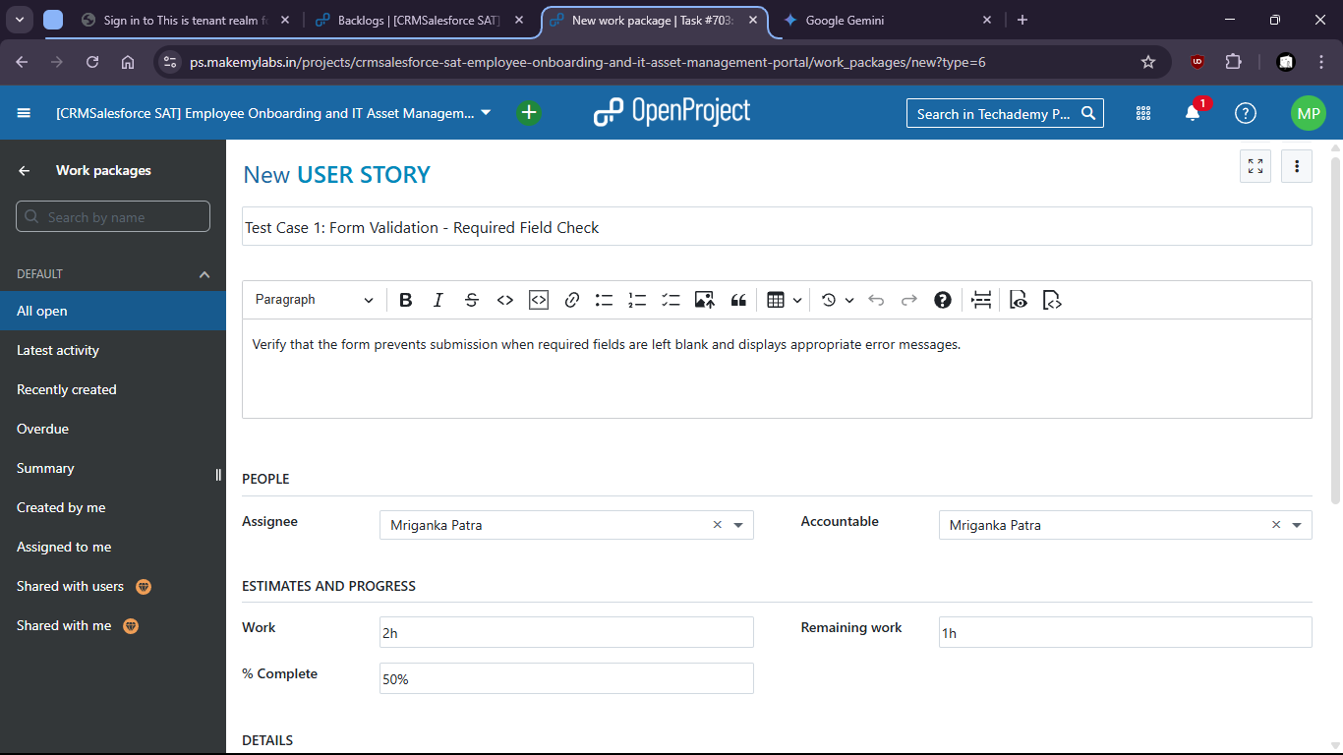
- Test for the SharePoint form if blank field shows any error.
- 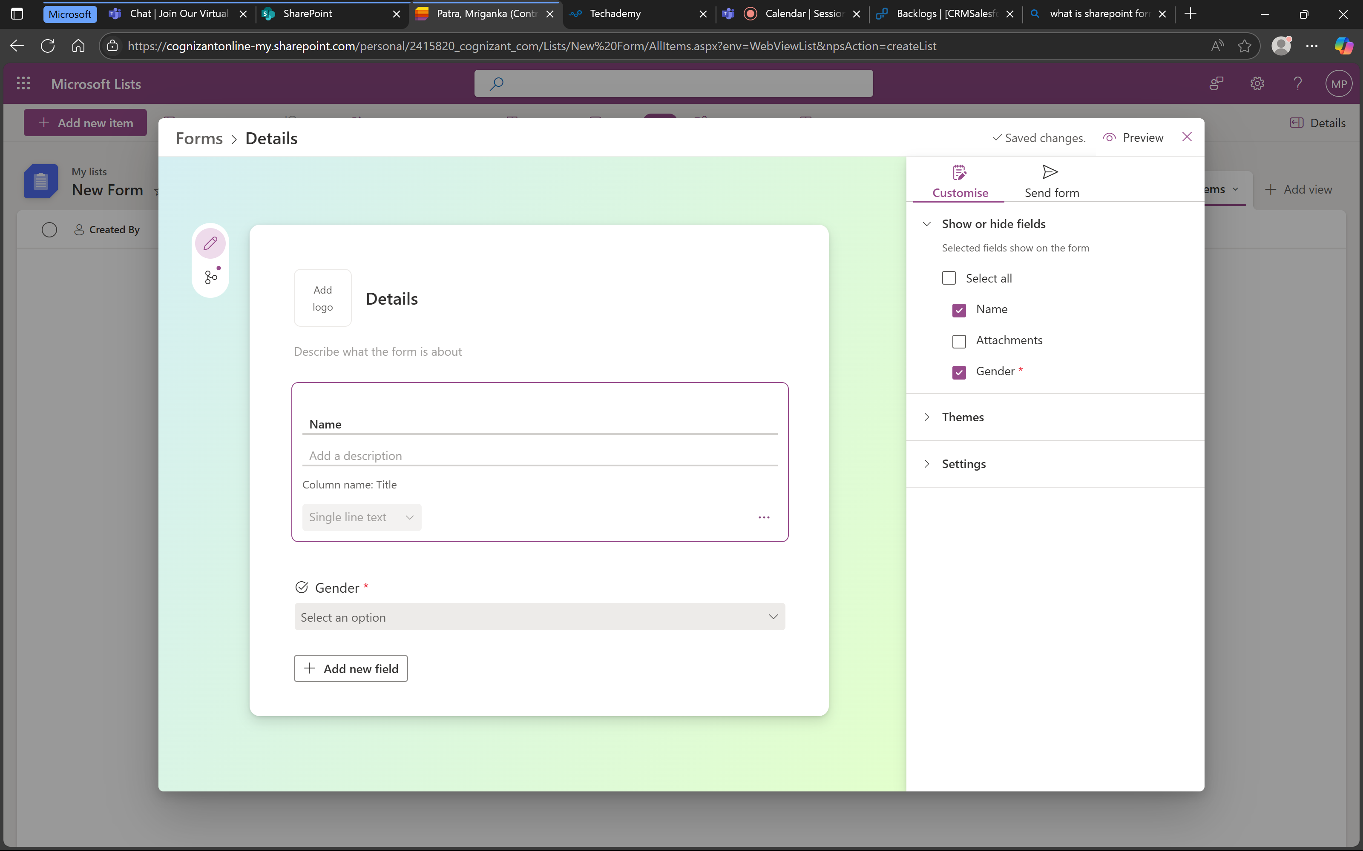

- When mandatory field gender is not filled it shows error message.
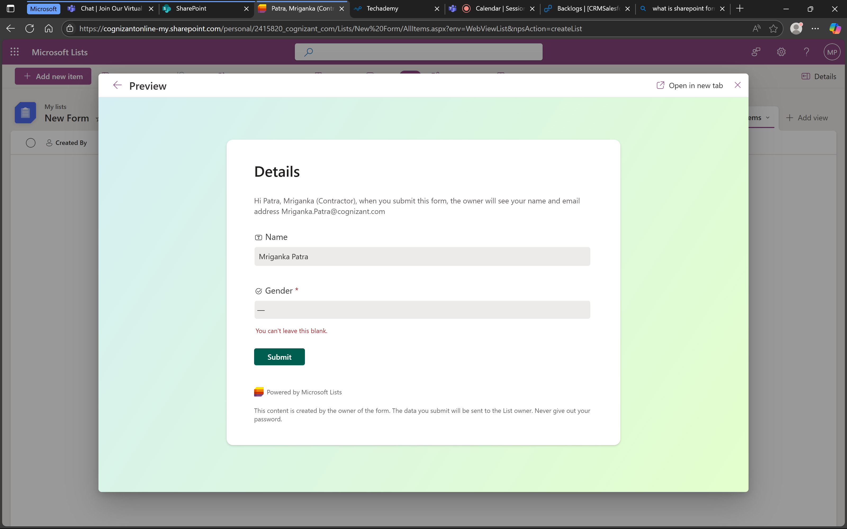

- Means that the form is working successfully.

Test Case 2: Data Type Validation - Invalid Input
Description: Verify that the form correctly validates input for specific data types (e.g., names, gender) and displays error messages for invalid entries.

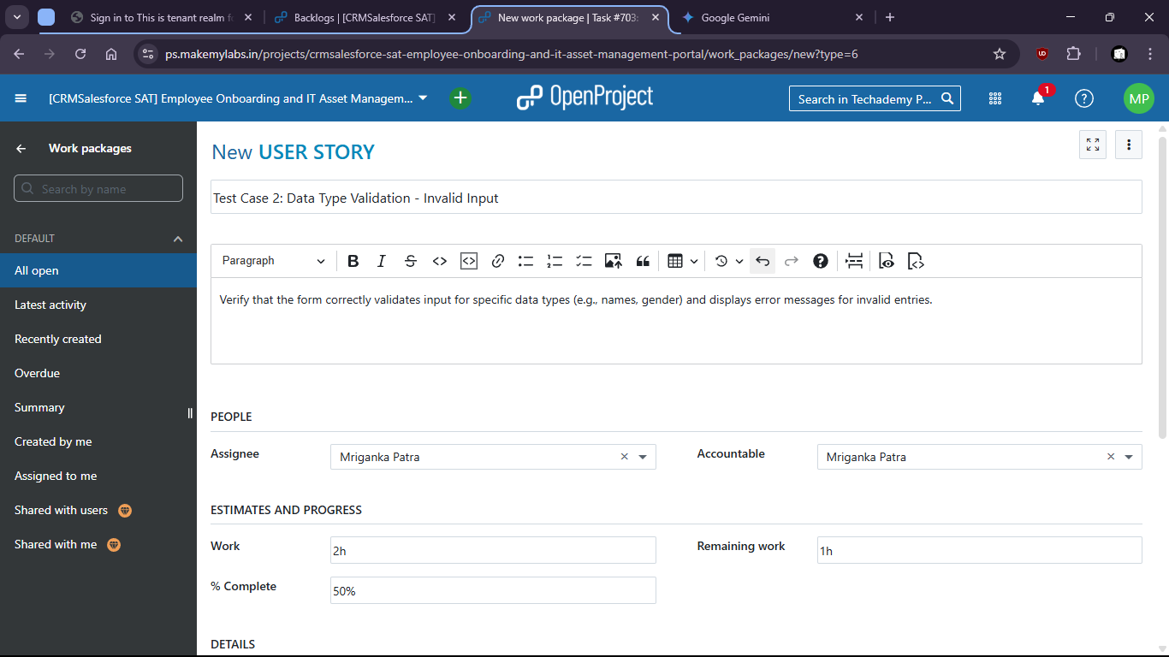

- There is no option to put invalid data and submit wrong format.
- Try to put invalid data in the filed like gender
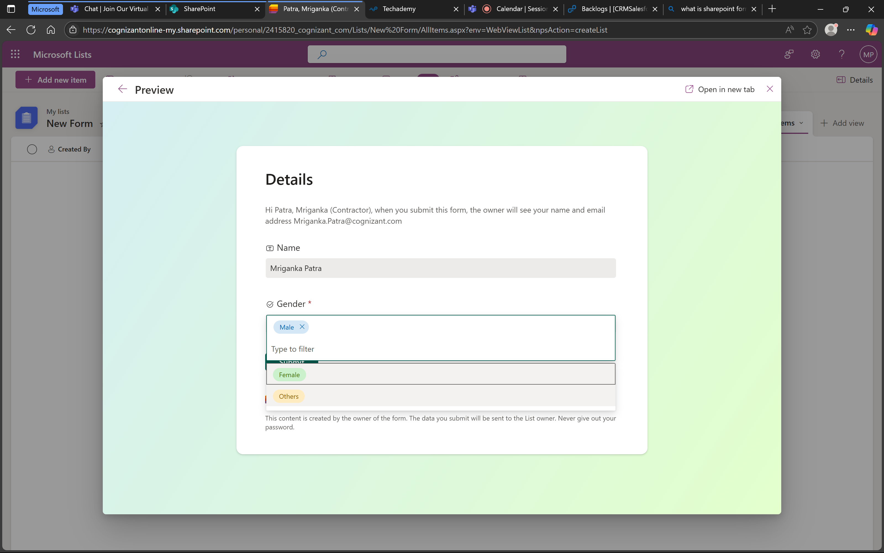
- There is no option to put invalid data.

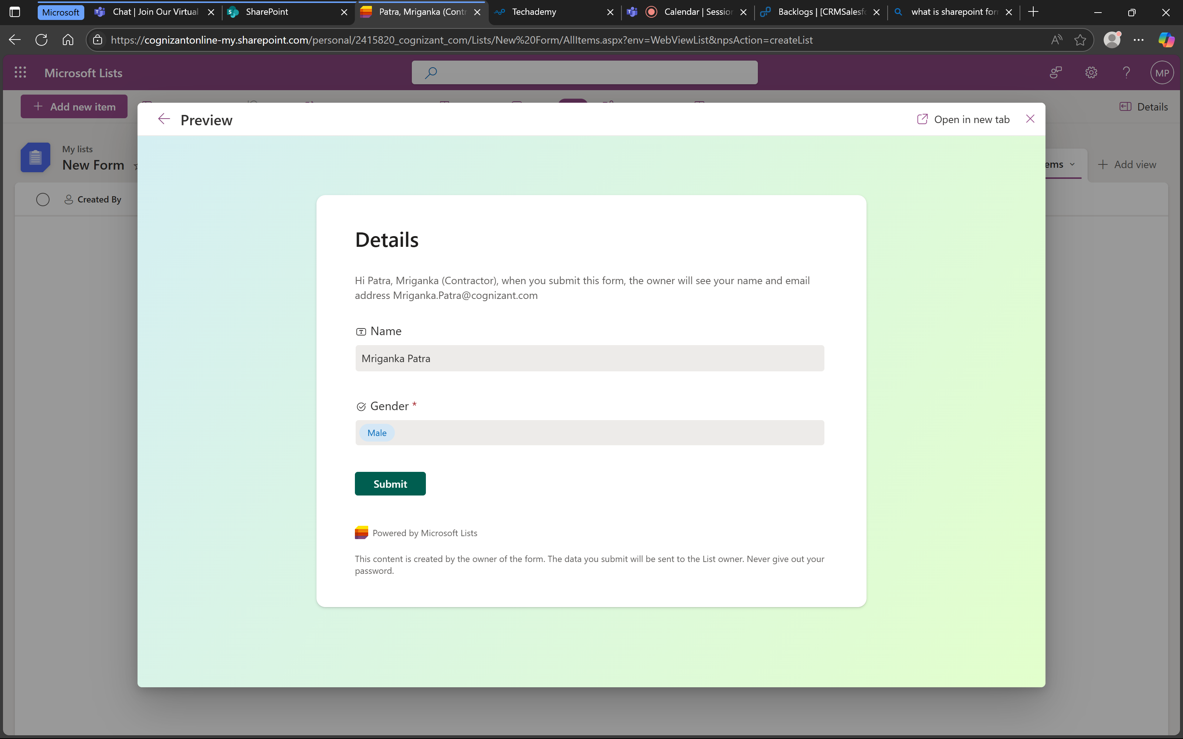
- That means the test is success and form is working as expected.
Test Case 3: Form Submission - Successful Submission
Description: Verify that a new item can be successfully created and saved through the SharePoint form.

- Check if the form is being submitted successfully.
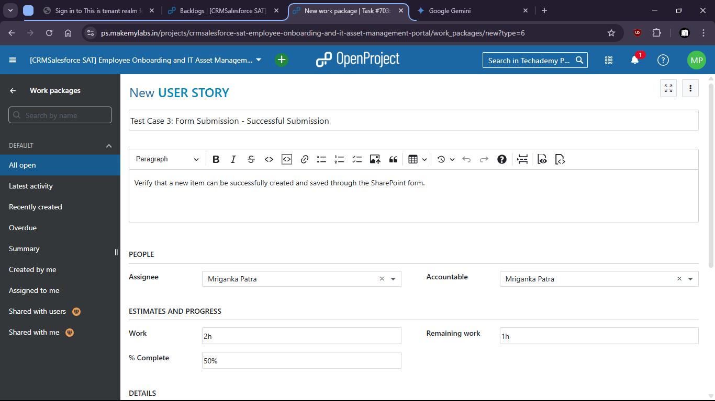

- Put valid data and submit the form.
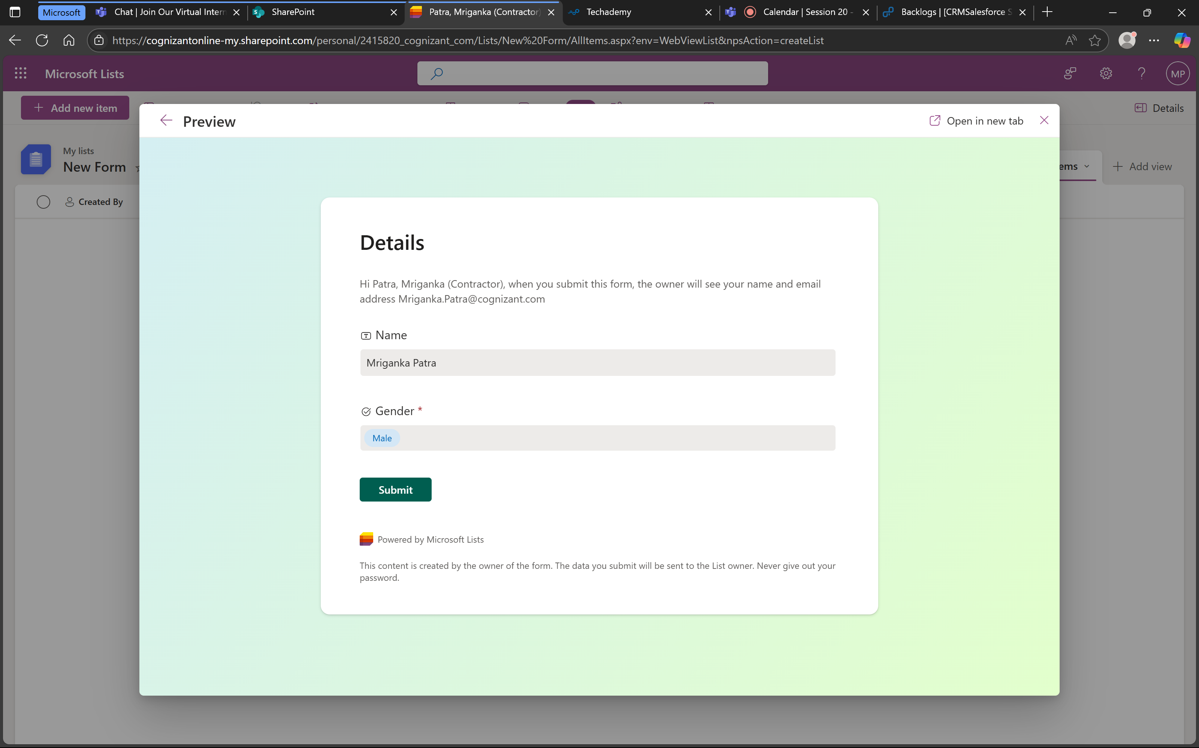

- Form is submitted.

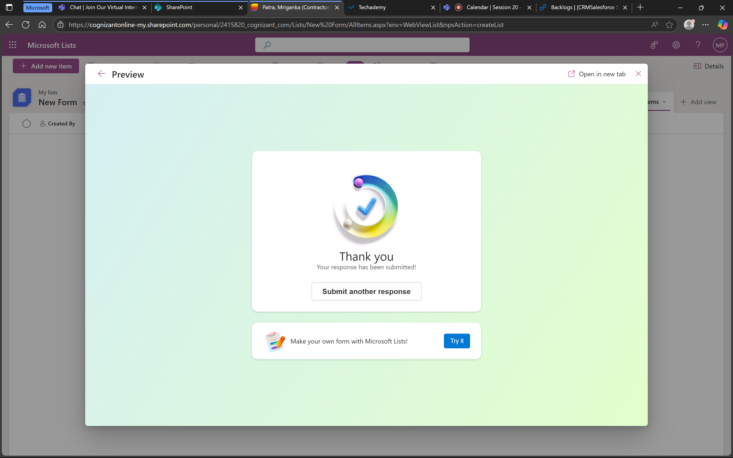

- Values are also stored successfully.
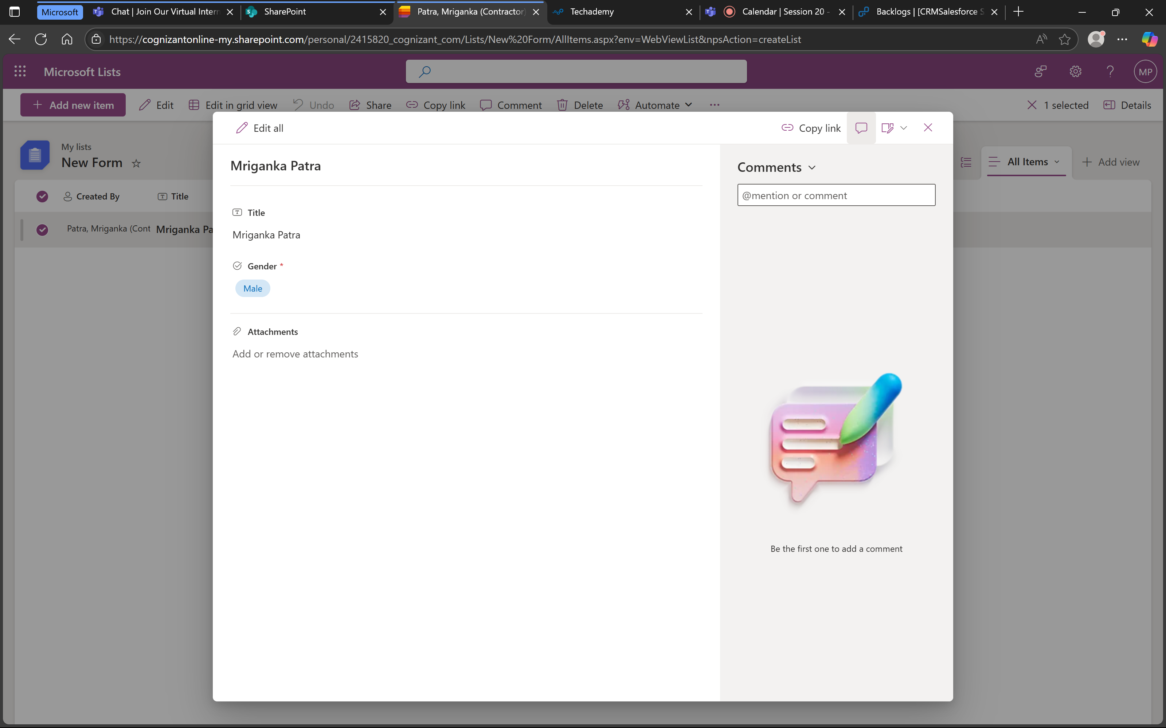

- That means the form is working successfully.

Test Case 4: Form Cancellation
Description: Verify that the form can be cancelled without creating an item.

- Check if after cancellation the data is being cleared.
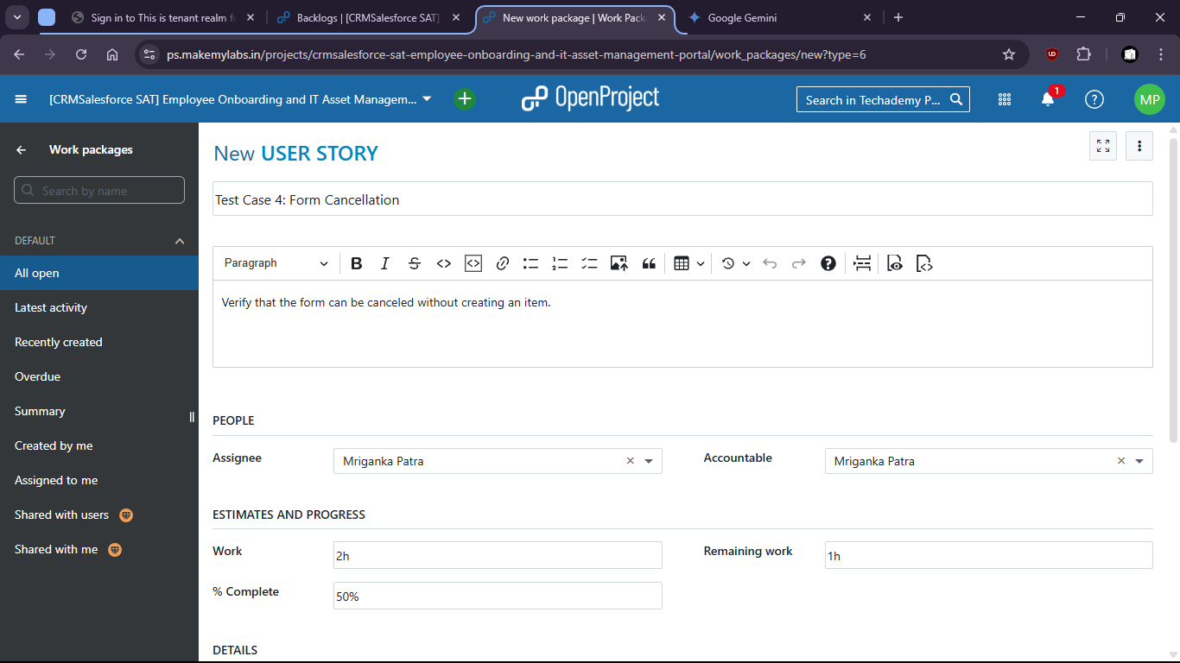

- Form is filled up
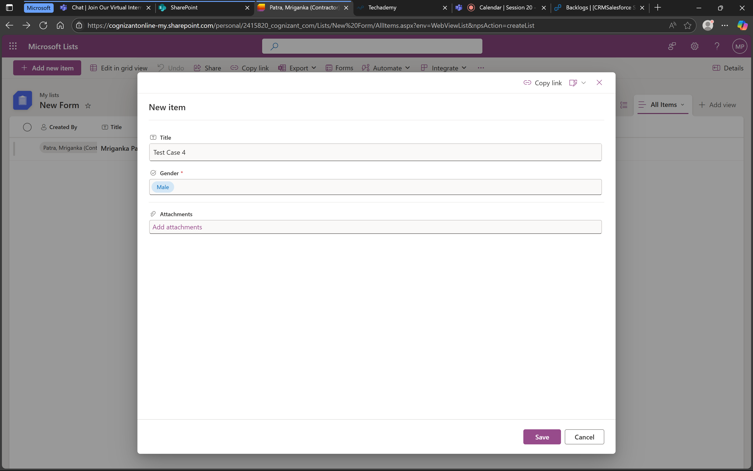

- Then it is cancelled:
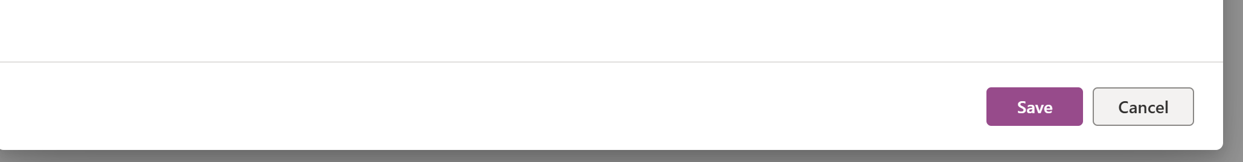

- We can check that no new form is created

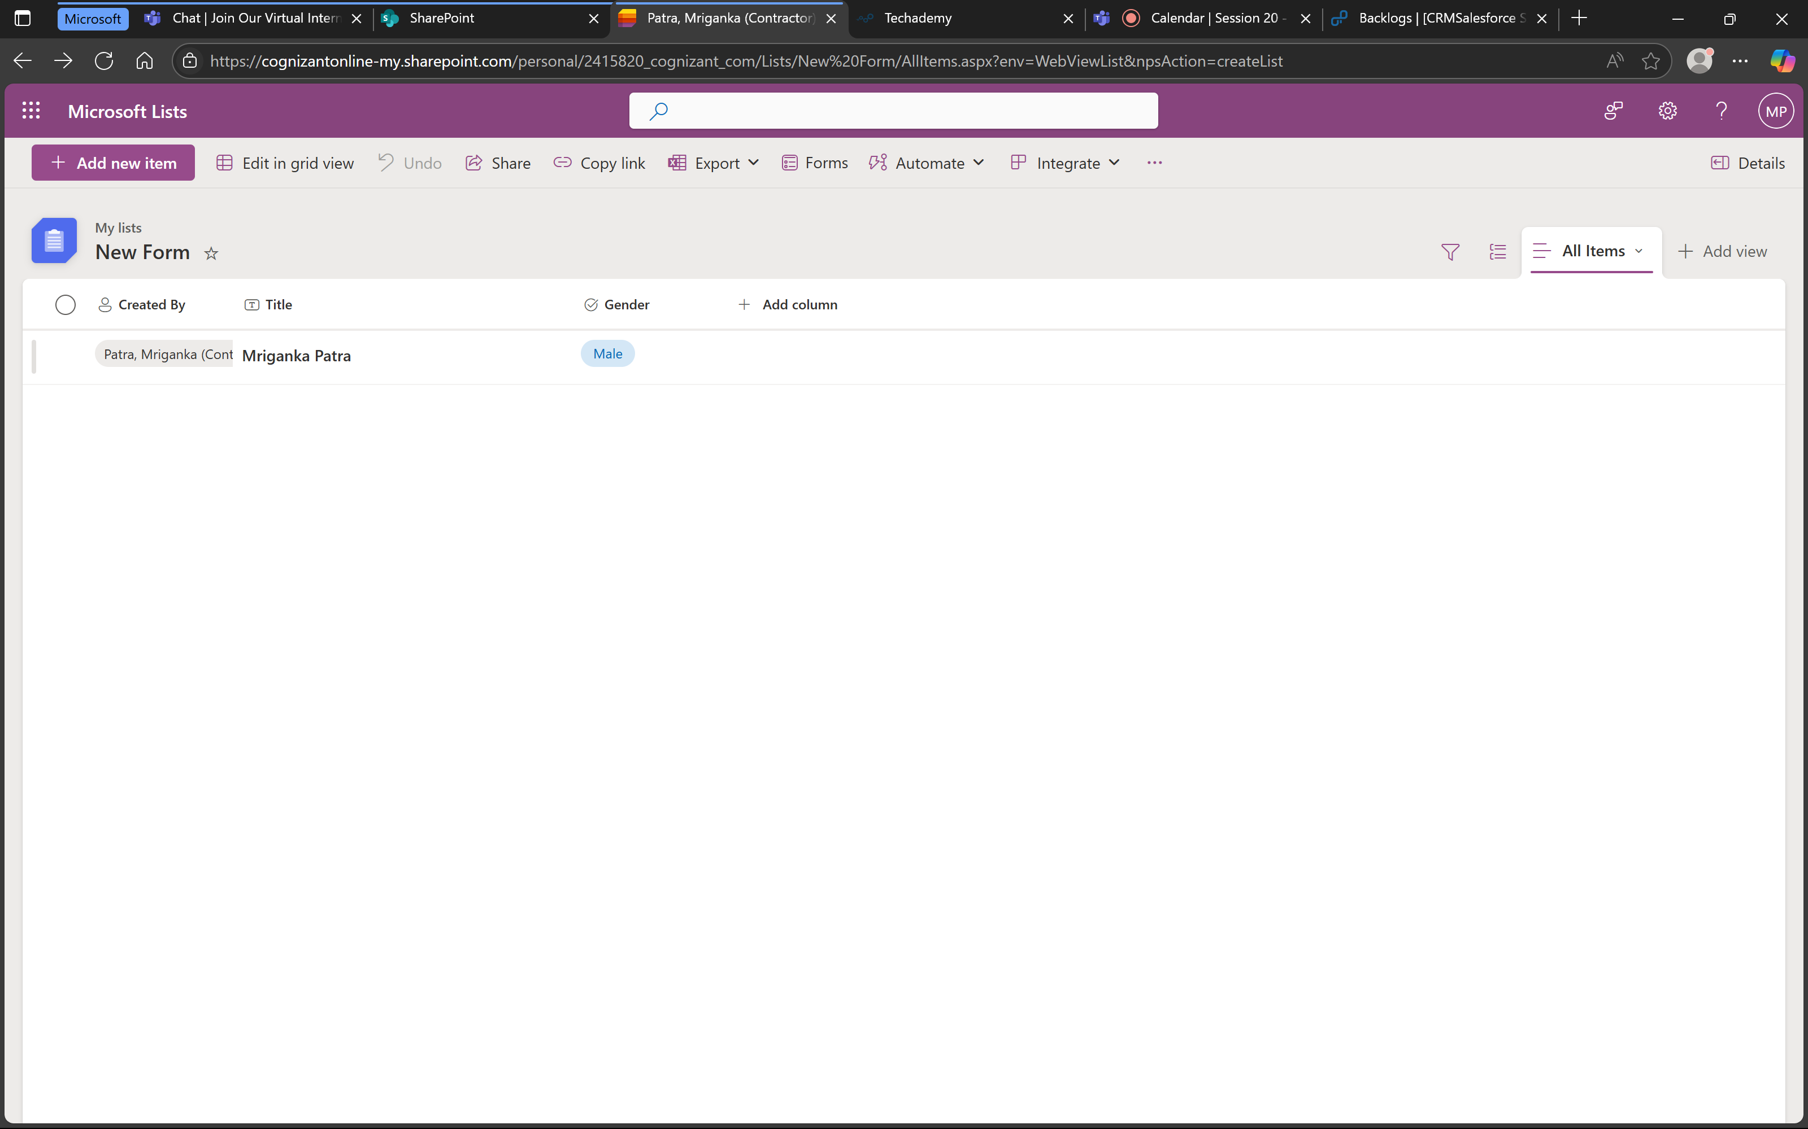

- That means the form does not store values after cancellation and is working as expected.

Under epic > task created and assigned (703)
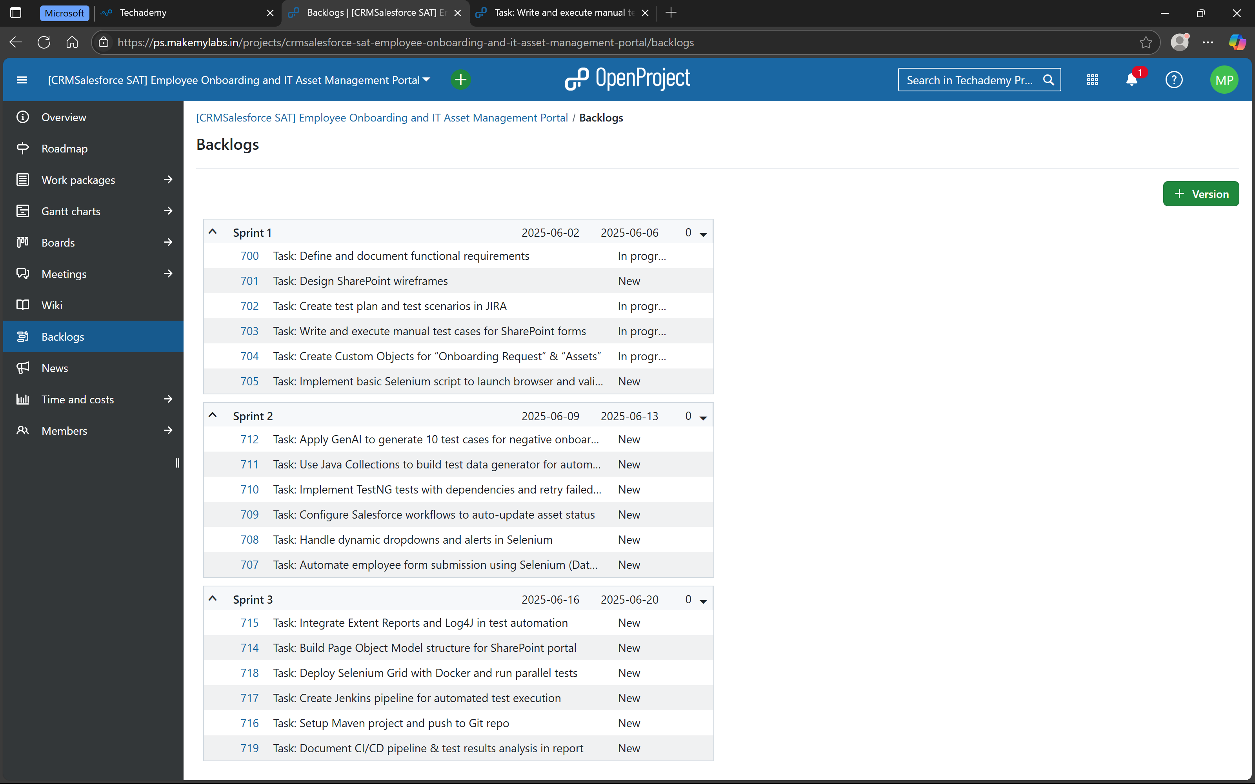

Under Task > user stories created and completed (with hierarchy)

